IAWA Gold Cup 2017
Venue: Croftfoot Scout Hall, 240 Ashcroft Drive, Croftfoot, Glasgow, G44 5QG
Date: 4th November 2017
Entry Fee: £30.00
Weightlifting Timetable: | 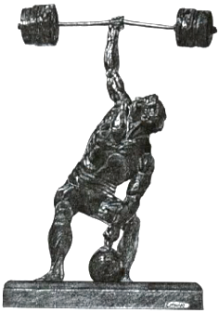
Weigh In: 9am to 10am Weightlifting Starts: 11am

Silver Cup entries (for those not holding a World Record) will lift first followed by Gold Cup

CLOSING DATE FOR ENTRIES: SATURDAY 21st OCTOBER (Firm)

Required Information:
Name: ………………………………………………………………………………………………………………………………………………………

Address: …………………………………………………………………………………………………………………………………………………..

Date of Birth: ……………………………………………………………………………………………………………………………………………

Age Group: ……………………………………………………………………………………………………………………………………………….

Weight Category: ……………………………………………………………………………………………………………………………………..

1st Choice Lift: …………………………………………………………………………………………………………………………………………..

2nd Choice Lift: ………………………………………………………………………………………………………………………………………….

Home Phone Number: ……………………………………………………………………………………………………………………………..

Mobile: …………………………………………………………………………………………………………………………………………………….

E-mail: ……………………………………………………………………………………………………………………………………………………..

Signed:………………………………………………………………………………………………………………………………………………………

Banquet & Awards Ceremony
£20.00 per head (Two Courses) if you want more on the day you can pay separately

Ivory Hotel Address: 2-4 Camphill Avenue, Glasgow, G41 3AY
Tel: 0141 636 0223, e-mail enquiries@ivoryhotel.com, Web site: http://www.ivoryhotel.com

Number for meal: ……………………………………………………………………… Total fee: ………………………………

Further Information: Contact email for all enquiries: matthewfinkle@gmail.com, Tel: 44 (0) 7736 808645
Cheques to be Made Payable to: Matthew Finkle
Send forms to: IAWA Gold Cup, Matthew Finkle, 7 Ardencraig Drive, Castlemilk, Glasgow, G45 0HD

Joint Promoters of the 2017 Gold Cup: Mathew Finkle and Andrew Tomlin

