IAWA Gold Cup 2018
Venue: MetamorFIT, 5F Southbourne Bus. Park. Courtlands Road. Eastbourne BN22 8UY
Date: 13th October 2018
Entry Fee: £30.00
Weightlifting Timetable: | 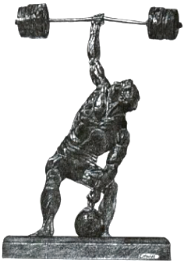
Weigh In: 9am to 10am Weightlifting Starts: 11am

Silver Cup entries (for those not holding a World Record) will lift first followed by Gold Cup

CLOSING DATE FOR ENTRIES: Saturday 29th September 2018

Required Information:
Name: ………………………………………………………………………………………………………………………………………………………

Address: …………………………………………………………………………………………………………………………………………………..

Date of Birth: ……………………………………………………………………………………………………………………………………………

Age Group: ……………………………………………………………………………………………………………………………………………….

Weight Category: ……………………………………………………………………………………………………………………………………..

1st Choice Lift: …………………………………………………………………………………Approx poundage?..………………………..

2nd Choice Lift: ……………………………………………………………………………….Approx poundage?………………………….

Home Phone Number: ……………………………………………………………………………………………………………………………..

Mobile: …………………………………………………………………………………………………………………………………………………….

E-mail: ……………………………………………………………………………………………………………………………………………………..

Signed:………………………………………………………………………………………………………………………………………………………

Banquet & Awards Ceremony
£25.00 per head (Three Courses. Menu choices will be required in advance - See info sheet)

Venue: The Hydro Hotel Address: Mount Road, Eastbourne, East Sussex BN20 7HZ
Tel: 44 (0) 1323 720643 Website: www.hydrohotel.com

Number for meal: ……………………………………………………………………… Total fee: ………………………………

Further Information: Contact promoter Paul Barette - email for all enquiries: iawa@metamorfit.co.uk, Tel: 44 (0) 1323 726833 or +44 (0) 7710 659744
Cheques to be Made Payable to: Paul Barette / PayPal entries to paul@metamorfit.co.uk (to avoid PayPal charges please ensure you use the pay friend/relative option)
Send forms to: MetamorFIT, 5F Southbourne Bus Park. Courtlands Rd. Eastbourne BN22 8UY

